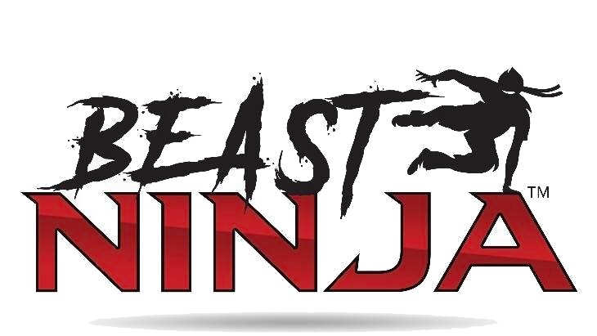
2024
New Year Special!
All new members who sign up during the month of January will get 50% off the 3rd full month for any new contract.
No Enrollment Fee!

